HTML Interview Question’s

**1.What is HTML?**

HTML stands for Hyper Text Markup Language. It is a universal language which allows an individual using special code to create web pages to be viewed on internet.

**2. What is a HTML tag?**

HTML tags tells the browser what to do. Tags are the keywords that defines the format of a web page. HTML tags are used to create HTML documents and render their properties. Each HTML tags have different properties.

Some basic HTML tags are:

<!DOCTYPE> : Defines the document type

<html>: Defines an HTML document

<head>: Contains metadata/information for the document

<title>: Defines a title for the document

<body>: Defines the document's body

<h1> to <h6>: Defines HTML headings

<p>: Defines a paragraph

<br> : Inserts a single line break

<hr> : Defines a thematic change in the content

### ****3. What is meta element in HTML?****

The meta element is used to provide additional information about a document. The meta tag has no content; rather, all of the information provided is specified with attributes.

The two attributes that are used to provide information are name and content. The user makes up a name as the value of the name attribute and specifies information through the content attribute.

One commonly chosen name is keywords; the value of the content attribute associated with the keywords are those which the author of a document believes characterizes his or her document.

### ****4. What are HTML forms?****

An HTML form is used to allow a user to input data on a web page and the element used is form element and its main attributes are action and method.

The most common way for a user to communicate information from a Web browser to the server is through a form. XHTML provides tags to generate the commonly used objects on a screen form. These objects are called controls or widgets. There are controls for single-line and multiple-line text collection, checkboxes, radio buttons, and menus, among others. All control tags are inline tags.

### ****5. What are some text formatting tags in HTML?****

1.<p> </p> - is used for introducing various paragraphs.

2.<br> - this tag is used for giving an empty blank line.

2.HEADING TAGS - <h1> </h1> .. <h6> </h6> is used to introduce various headings. <h1> is the biggest and <h6> is the smallest heading tag.

3.<HR> TAG – is used to draw lines and horizontal rules.

4.<B>,<I>,<U> for bold, italic and underline respectively.

### ****6. What do you mean by row spanning and column spanning?****

Row spanning is used to merge (combine) two or more rows.

Column spanning is used to merge (combine) two or more columns.

### ****7. What is table tag? write syntax.****

A table is a two dimensional matrix, consisting of rows and columns. All table related tags are included between <TABLE> </TABLE> tags.

### ****8. What do you mean by horizontal rules in HTML?****

The parts of a document can be separated from each other, making the document easier to read, by placing horizontal lines between them.

### ****9. What are Style Sheets?****

Style sheets are collections of style information that are applied to plain text.

### ****10. List down the ways of including style information in a document.****

1.Linked Styles -Style information is read from a separate file that is specified in the <LINK> tag

2.Embedded Styles -Style information is defined in the document head using the <STYLE> and </STYLE> tags.

3.Inline Styles -Style information is placed inside an HTML tag and applies to all content between that tag and it's companion closing tag.

### ****11. Define cascading.****

Cascading refers to a certain set of rules that browsers use, in cascading order, to determine how to use the style information. Such a set of rules is useful in the event of conflicting style information because the rules would give the browser a way to determine which style is given precedence.

### 12.What are HTML Attributes?

### Attributes are the properties that can be added to an HTML tag.

### In HTML, attributes are additional pieces of information provided inside the opening tag of an element to modify or provide more details about that element. Attributes usually come in name/value pairs like name="value", and they enhance the functionality and behavior of HTML elements.

### 13.What is a marquee in HTML?

### Marquee is used for scrolling text on a web page. It scrolls the image or text up, down, left, or right automatically. To apply for a marquee, you have to use </marquee> tags.

### 14.Define the list types in HTML?

* Ordered list–The ordered list uses <ol> tag and displays elements in a numbered format.
* Unordered list–The unordered list uses <ul> tag and displays elements in a bulleted format.
* Definition list–The definition list uses <dl>, <dt>, <dd> tags and displays elements in definition form like in a dictionary.

### 15. What is the difference between HTML and CSS?

### HTML is used to create the structure and content of a web page, while CSS is used to define the appearance and layout of the page.

### ***********************************************************************************************

### Intermediate HTML Interview Questions and Answers

### 1. Are the HTML tags and elements the same thing?

No, HTML tags are used to define the structure of a web page, while HTML elements are made up of a set of tags that define a specific part of a web page.

### 2. What are void elements in HTML?

Void elements in HTML are tags that do not require a closing tag. They are used to insert images, line breaks, and other content that does not require additional information.

### 3. What is the advantage of collapsing white space?**

Collapsing white space in HTML can help to reduce the size of web pages and make them load faster. It involves removing unnecessary white space between HTML elements.

### 4. What are HTML Entities?**

HTML Entities are special characters used to represent characters that cannot be typed on a keyboard. They are often used to display special symbols and foreign characters.

### 5. How do you insert a copyright symbol in HTML?

You can insert a copyright symbol by using &copy; or &#169; in an HTML file.

### 6.How do you create links to different sections within the same HTML web page?

We use the <a> tag, along with referencing through the use of the # symbol, to create several links to different sections within the same web page.

### 7. How do you create a hyperlink in HTML?

We use the anchor tag <a> to create a hyperlink in HTML that links one page to another page. The hyperlink can be added to images too. (**href** is **Hypertext Reference**.)

### 8.what is semantic tag?

### It is a meaningful tag for example: <header> tag.

### semantic tags apart form providing meaning to the developer does it helps in any other way?

### Enhanced SEO (Search Engine Optimization)

### Semantic tags help search engines understand the structure and content of a web page. Search engines like Google prioritize content that is well-structured and meaningful. By using semantic tags, you can improve your page's visibility and ranking in search engine results

### 9.How do you create nested web pages in HTML?

Nested web pages basically mean a webpage within a webpage. We can create nested web pages in HTML using the built-in I frame tag.

### 10. What is the difference between the ‘id' and ‘class' attributes of HTML elements?

The ‘id' attribute defines a unique identifier for an HTML element, while the ‘class' attribute defines a class for a group of elements. An ‘id' can only be used once on a page, while a ‘class' can be used multiple times.

### 11.What is the difference between HTML and XHTML?

HTML and XHTML are both markup languages used to create web pages. However, XHTML is stricter than HTML and requires developers to write well-formed code that adheres to specific rules and guidelines. XHTML also requires all tags to be closed and all attributes to be quoted.

### 12.What are the different types of form input fields in HTML?

Several form input fields in HTML include text fields, checkboxes, radio buttons, select menus, and text areas. Each input field type is used to collect different types of data from users.

### 13.What is the role of the method attribute in HTML forms?

The method attribute is used to specify the HTTP method that will be used to submit the form data. The two most common methods are GET and POST. GET is used to retrieve data from the server, while POST is used to send data to the server.

### 14.What is the difference between link tag <link> and anchor tag <a>?

The <link> tag links external resources, such as CSS stylesheets, to an HTML document. The <a> tag creates links to other pages or resources within the same document.

**15.Difference between tags and element?**

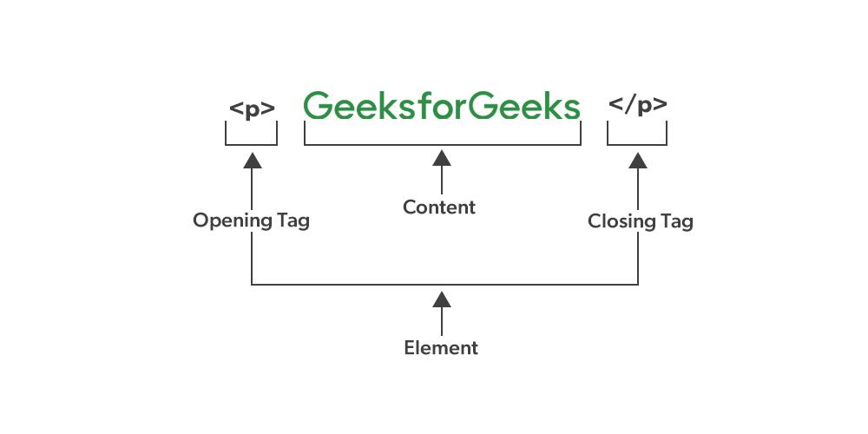

**Canvas?**

1. **Definition :** <canvas> is an HTML element used to draw graphics on the fly via scripting (usually JavaScript). It is a bitmap-based graphics system.
2. **Drawing Model:** Raster-based: The graphics drawn on a <canvas> are made up of pixels.
3. **Usage:** Ideal for real-time drawing, game graphics, and image processing.Best for complex and intensive graphic operations, such as animation and gaming.
4. **Performance:** Generally faster for complex graphics and animations since it directly manipulates pixels.
5. **Interactivity**: Limited built-in interactivity. Interaction must be manually managed via JavaScript event handling**.**
6. **Scalability:** Not inherently scalable. Scaling a <canvas> element often results in loss of quality because the graphics are pixel-based.
7. **Manipulation**: Once graphics are drawn, they become part of the canvas and can't be manipulated individually without redrawing the entire canvas.

**•**

**SVG?**

1. **Definition**: SVG is an XML-based markup language for describing two-dimensional vector graphics.
2. **Drawing Model**: Vector-based: The graphics are defined in terms of paths, shapes, and other geometric and text elements.
3. **Usage**: Ideal for static images, illustrations, and graphics that require high scalability.Best for graphics that require precise control over each element, such as diagrams, charts, and icons.
4. **Performance**: Generally slower for complex graphics and animations compared to <canvas>, but efficient for simpler or static images.
5. **Interactivity**: Highly interactive with built-in support for event handling. Each element in an SVG image can have its own event handlers.
6. **Scalability**: Inherently scalable without loss of quality because the graphics are vector-based.
7. **Manipulation**: Individual elements can be easily manipulated through JavaScript and CSS.

**Difference between box-sizing border-box and without?**

